COLUMBIA CHAMBER BALLET 2019 NUTCRACKER TOUR!
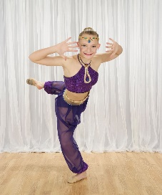 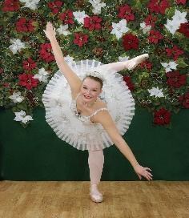 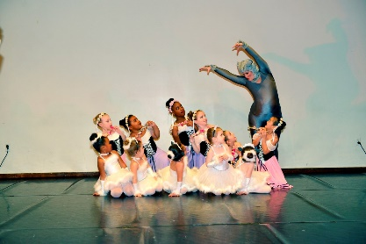 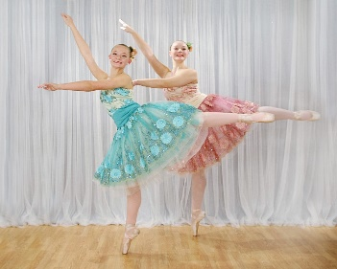Columbia, MD, - The Columbia Chamber Ballet, established in 1990, the performing company of Ballet with Cindee Velle, from the Long Reach Village Center in Columbia, MD, will once again take to the road with an abbreviated, performance of the holiday dance favorite, “The Nutcracker”. This performance is enjoyable for all ages and runs approximately one hour in length. Dance selections include Dolls, Children’s March,Clara, The Battle Scene, Snowflakes, Candy Canes, Chinese, Spanish, Arabian, The Sugar Plum Fairy, Merlitons with Sheep, Flowers and many more magical characters! (Photography by starlight123.com)
The following shows are open to the public:

- Sunday Dec. 1st 3:00PM – The Kennedy Krieger Festival of Trees; MD State Fairground, 2200 York Road Timonium, MD 21093. For tickets visit www.festivaloftrees.kennedykrieger.org/tickets

- Sunday Dec. 8th at 3:00PM – SOLD OUT! Stonehouse; Long Reach Community Association. 8775 Cloudleap Court, Columbia, MD 21045. Free admission. Advance reservations starting November 4th (limited seating), bcv-nutcracker.evenbrite.com to reserve your seats.

- Tuesday Dec. 17th at 7:30PM – The Great Room; Historic Savage Mill, 8600 Foundry St., Savage, MD 20763 $10 admission for ages 2 & up. Buy tickets on line at www.cindeevelleballet.com *

- Saturday Dec. 21st at 7:30PM - Howard County Arts Council; 8510 High Ridge Road, Ellicott City, MD 21043. $10 admission for ages 2 & up. Tickets on sale at www.cindeevelleballet.com *

*Based on availability, tickets will be sold at the door.

