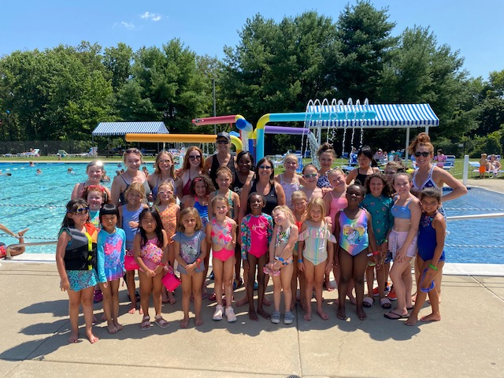
BCV SUMMER DANCE CAMP 2022!

Looking for a fun experience for your child? Come dance with us at Dance Camp!

Camp meets the week of August 1st through August 5th. It is an all-day program from 8:30AM to 5PM. The cost is $375, payable to The Long Reach Community Association. Registration will open March 1st at www.cindeevelleballet.com. We meet at Stonehouse, in the Long Reach Community Association, 6110 Foreland Garth, Columbia, MD 21045. This camp is for students entering grades Kindergarten-8th in the Fall of 2022.
Students participate every morning in Ballet, Jazz and Lyrical class. After lunch we will walk to a nearby neighborhood pool for a swim or partake in other outdoor activities. Included in the day’s activities are Arts and Crafts. Please see our website for our current COVID-19 Guidelines.

The week concludes in a performance for family and friends on Friday afternoon. Participants are required to wear a black or pink leotard, pink or beige tights, pink Ballet shoes and black or beige Jazz shoes. There is also a $35 activity fee (Payable to Ballet with Cindee Velle) in addition to the $375 tuition. Call 410-465-7674 for more information or email cindeevelleballet@verizon.net.

SPACES ARE LIMITED. SIGN UP ASAP!

