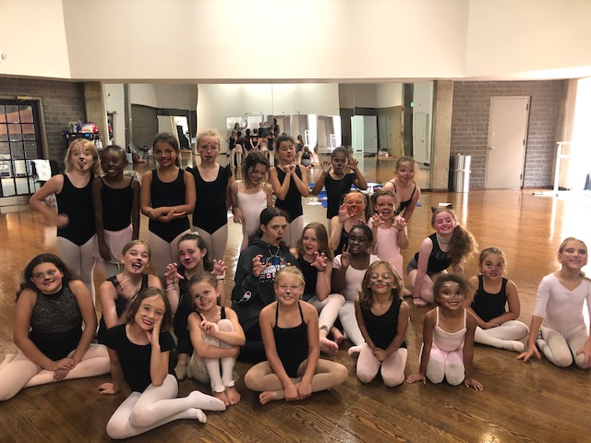
BCV SUMMER DANCE CAMP 2023!

Looking for a fun experience for your child? Come dance with us at Dance Camp!

Camp will be at 9147 Red Branch Road, Suite D, E, F Columbia, MD 21045

New this year, we will have two sessions of dance camp. The first session will meet on July 31st – August 4th and the second session will meet on August 7th – August 11th. It is an all-day program from 8:30AM to 5PM. The cost is $430, which includes the $35 activity fee. Please make payments online payable to Ballet with Cindee, LLC. Registration will open February 15th at www.cindeevelleballet.com. This camp is for students entering grades Kindergarten-8th in the Fall of 2023.

Students participate every morning in Ballet, Jazz and Lyrical class. We walk to a nearby neighborhood pool for a swim or partake in other outdoor activities, weather permitting. Daily activities include Arts and Crafts. The week concludes in a performance for family and friends on Friday afternoon. Participants are required to wear leotards, tights Ballet, Jazz and Lyrical shoes if possible. For more information call 410-465-7674.

