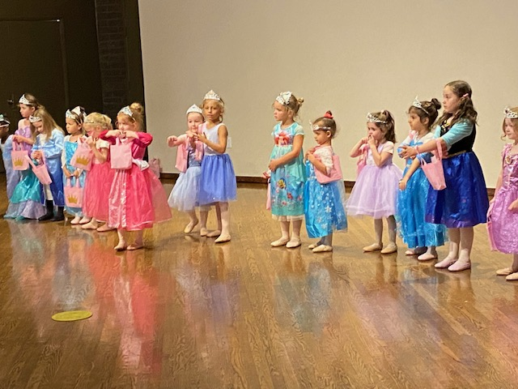

**BCV PRINCESS CAMP 2023!**

Looking for a fun experience for your child? Come dance with us at Princess Camp!

Camp will be at 9147 Red Branch Road, Suite D, E, F Columbia, MD 21045

We will have two sessions of princess camp. The first session will meet on August 14th – August 18th and the second session will meet on August 21st – August 25th. It is a half day program from 9AM to 12PM. The cost is $235. Please make payments online payable to Ballet with Cindee, LLC. Registration will open February 15th at [www.cindeevelleballet.com](http://www.cindeevelleballet.com). This camp is for students ages 3-6.

Each day students will learn a new princess dance and learn the qualities that make each princess/prince unique. At the end of the week, the dancers will perform for their parents and friends and participate in a coronation ceremony. Dress code for girls is pink leather or pink canvas ballet slippers, pink tights with feet and a pink leotard. Dress code for boys is black leather or black canvas ballet slippers or black jazz shoes, a white t-shirt and black sweatpants. Sign up for both sessions and receive $25 off per week. For more information call 410-465-7674.

|  |  |  |  |
| --- | --- | --- | --- |
| |  |  | | --- | --- | | |  | | --- | |  | | |  | |